1 run......

Downloading: 100%

411/411 [00:00<00:00, 6.26kB/s]

Downloading: 100%

263M/263M [00:09<00:00, 29.3MB/s]

training 1 epoch...

521.923853635788 seconds used......

1 training finished! average train loss: 0.2839689408823277

evaluating...

Confusion matrix, without normalization

[[ 89 183 22]

[ 63 3686 72]

[ 3 106 733]]

Normalized confusion matrix

[[0.30272109 0.62244898 0.07482993]

[0.01648783 0.96466893 0.01884323]

[0.00356295 0.12589074 0.87054632]]

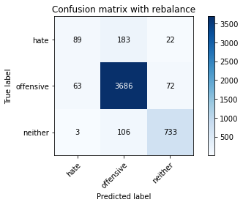

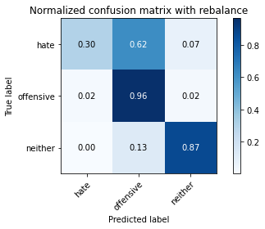

precision recall f1-score support

hate 0.57 0.30 0.40 294

offensive 0.93 0.96 0.95 3821

neither 0.89 0.87 0.88 842

accuracy 0.91 4957

macro avg 0.80 0.71 0.74 4957

weighted avg 0.90 0.91 0.90 4957

average eval_loss: 0.2523246462186498, accuracy: 0.9094210207786968

training 2 epoch...

521.7853081226349 seconds used......

2 training finished! average train loss: 0.2036479640566188

evaluating...

Confusion matrix, without normalization

[[ 127 151 16]

[ 107 3648 66]

[ 19 83 740]]

Normalized confusion matrix

[[0.43197279 0.51360544 0.05442177]

[0.02800314 0.95472389 0.01727297]

[0.02256532 0.09857482 0.87885986]]

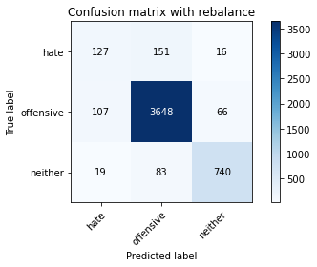

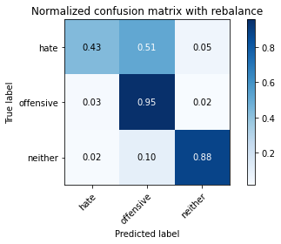

precision recall f1-score support

hate 0.50 0.43 0.46 294

offensive 0.94 0.95 0.95 3821

neither 0.90 0.88 0.89 842

accuracy 0.91 4957

macro avg 0.78 0.76 0.77 4957

weighted avg 0.91 0.91 0.91 4957

average eval_loss: 0.2419844346962148, accuracy: 0.9108331652208997

training 3 epoch...

521.510383605957 seconds used......

3 training finished! average train loss: 0.14132499639433058

evaluating...

Confusion matrix, without normalization

[[ 130 145 19]

[ 114 3628 79]

[ 19 65 758]]

Normalized confusion matrix

[[0.44217687 0.49319728 0.06462585]

[0.02983512 0.94948966 0.02067522]

[0.02256532 0.07719715 0.90023753]]

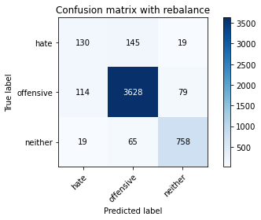

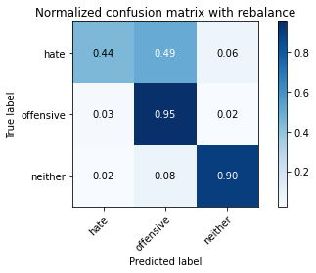

precision recall f1-score support

hate 0.49 0.44 0.47 294

offensive 0.95 0.95 0.95 3821

neither 0.89 0.90 0.89 842

accuracy 0.91 4957

macro avg 0.78 0.76 0.77 4957

weighted avg 0.91 0.91 0.91 4957

average eval_loss: 0.2739614827592196, accuracy: 0.9110349001412145

training 4 epoch...

522.0028986930847 seconds used......

4 training finished! average train loss: 0.08247935133253885

evaluating...

Confusion matrix, without normalization

[[ 99 173 22]

[ 88 3638 95]

[ 13 69 760]]

Normalized confusion matrix

[[0.33673469 0.58843537 0.07482993]

[0.02303062 0.95210678 0.0248626 ]

[0.01543943 0.08194774 0.90261283]]

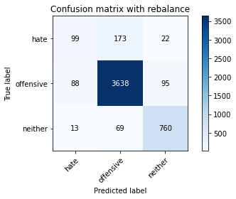

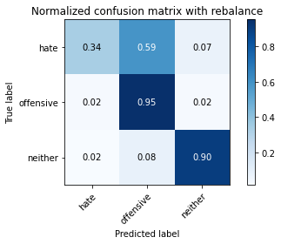

precision recall f1-score support

hate 0.49 0.34 0.40 294

offensive 0.94 0.95 0.94 3821

neither 0.87 0.90 0.88 842

accuracy 0.91 4957

macro avg 0.77 0.73 0.74 4957

weighted avg 0.90 0.91 0.90 4957

average eval_loss: 0.3566980132112099, accuracy: 0.9072019366552351

training 5 epoch...

521.6322596073151 seconds used......

5 training finished! average train loss: 0.04297502013303294

evaluating...

Confusion matrix, without normalization

[[ 121 156 17]

[ 98 3664 59]

[ 13 94 735]]

Normalized confusion matrix

[[0.41156463 0.53061224 0.05782313]

[0.02564774 0.95891128 0.01544098]

[0.01543943 0.11163895 0.87292162]]

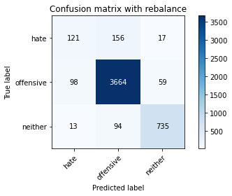

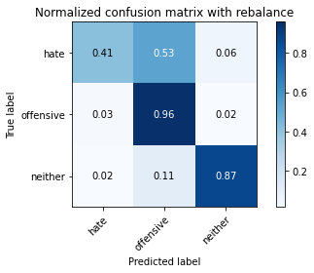

precision recall f1-score support

hate 0.52 0.41 0.46 294

offensive 0.94 0.96 0.95 3821

neither 0.91 0.87 0.89 842

accuracy 0.91 4957

macro avg 0.79 0.75 0.77 4957

weighted avg 0.91 0.91 0.91 4957

average eval_loss: 0.3622743024218747, accuracy: 0.9118418398224732

2 run

2 run......

Downloading: 100%

411/411 [00:00<00:00, 14.7kB/s]

Downloading: 100%

263M/263M [00:12<00:00, 22.5MB/s]

training 1 epoch...

514.4369161128998 seconds used......

1 training finished! average train loss: 0.28708640365080246

evaluating...

Confusion matrix, without normalization

[[ 32 226 36]

[ 24 3702 95]

[ 0 54 788]]

Normalized confusion matrix

[[0.10884354 0.76870748 0.12244898]

[0.00628108 0.96885632 0.0248626 ]

[0. 0.06413302 0.93586698]]

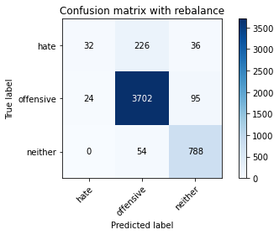

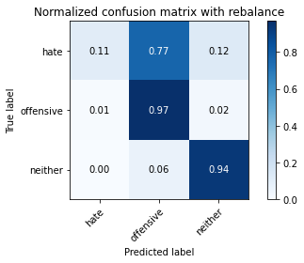

precision recall f1-score support

hate 0.57 0.11 0.18 294

offensive 0.93 0.97 0.95 3821

neither 0.86 0.94 0.89 842

accuracy 0.91 4957

macro avg 0.79 0.67 0.68 4957

weighted avg 0.90 0.91 0.89 4957

average eval_loss: 0.24288615860014914, accuracy: 0.9122453096631027

training 2 epoch...

513.9536678791046 seconds used......

2 training finished! average train loss: 0.20320832275601494

evaluating...

Confusion matrix, without normalization

[[ 64 215 15]

[ 41 3712 68]

[ 6 82 754]]

Normalized confusion matrix

[[0.21768707 0.73129252 0.05102041]

[0.01073018 0.97147344 0.01779639]

[0.00712589 0.09738717 0.89548694]]

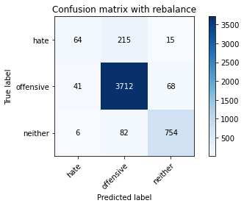

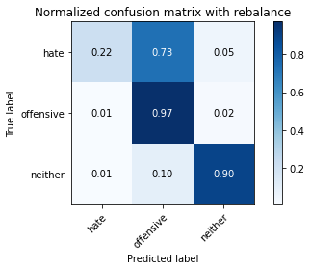

precision recall f1-score support

hate 0.58 0.22 0.32 294

offensive 0.93 0.97 0.95 3821

neither 0.90 0.90 0.90 842

accuracy 0.91 4957

macro avg 0.80 0.69 0.72 4957

weighted avg 0.90 0.91 0.90 4957

average eval_loss: 0.2356101750441256, accuracy: 0.9138591890256204

training 3 epoch...

514.1646521091461 seconds used......

3 training finished! average train loss: 0.144522730294416

evaluating...

Confusion matrix, without normalization

[[ 100 179 15]

[ 73 3691 57]

[ 13 119 710]]

Normalized confusion matrix

[[0.34013605 0.60884354 0.05102041]

[0.01910495 0.96597749 0.01491756]

[0.01543943 0.14133017 0.8432304 ]]

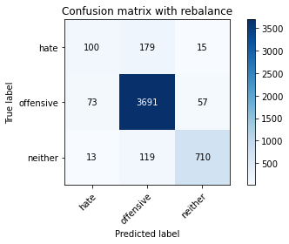

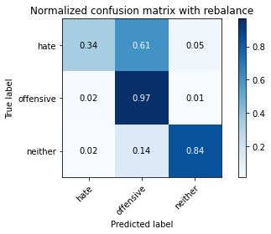

precision recall f1-score support

hate 0.54 0.34 0.42 294

offensive 0.93 0.97 0.95 3821

neither 0.91 0.84 0.87 842

accuracy 0.91 4957

macro avg 0.79 0.72 0.75 4957

weighted avg 0.90 0.91 0.90 4957

average eval_loss: 0.27582835850884174, accuracy: 0.9080088763364939

training 4 epoch...

513.5640668869019 seconds used......

4 training finished! average train loss: 0.08839800663237486

evaluating...

Confusion matrix, without normalization

[[ 109 164 21]

[ 99 3636 86]

[ 15 66 761]]

Normalized confusion matrix

[[0.3707483 0.55782313 0.07142857]

[0.02590945 0.95158336 0.0225072 ]

[0.01781473 0.0783848 0.90380048]]

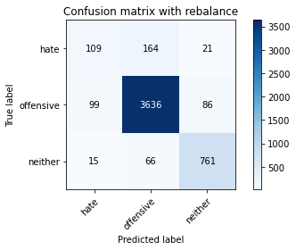

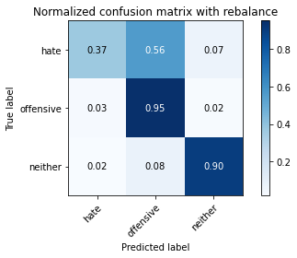

precision recall f1-score support

hate 0.49 0.37 0.42 294

offensive 0.94 0.95 0.95 3821

neither 0.88 0.90 0.89 842

accuracy 0.91 4957

macro avg 0.77 0.74 0.75 4957

weighted avg 0.90 0.91 0.91 4957

average eval_loss: 0.33844138828757303, accuracy: 0.9090175509380674

training 5 epoch...

514.027224779129 seconds used......

5 training finished! average train loss: 0.05071231442186599

evaluating...

Confusion matrix, without normalization

[[ 86 192 16]

[ 77 3670 74]

[ 8 100 734]]

Normalized confusion matrix

[[0.29251701 0.65306122 0.05442177]

[0.02015179 0.96048155 0.01936666]

[0.00950119 0.11876485 0.87173397]]

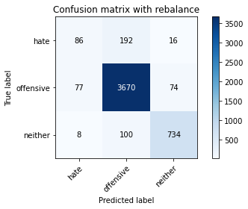

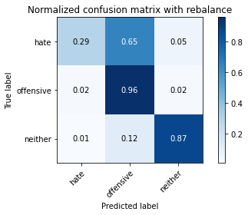

precision recall f1-score support

hate 0.50 0.29 0.37 294

offensive 0.93 0.96 0.94 3821

neither 0.89 0.87 0.88 842

accuracy 0.91 4957

macro avg 0.77 0.71 0.73 4957

weighted avg 0.90 0.91 0.90 4957

average eval_loss: 0.4087514111197379, accuracy: 0.9057897922130321

3 run......

training 1 epoch...

514.3336822986603 seconds used......

1 training finished! average train loss: 0.28157178569874247

evaluating...

Confusion matrix, without normalization

[[ 119 154 21]

[ 108 3633 80]

[ 12 64 766]]

Normalized confusion matrix

[[0.4047619 0.52380952 0.07142857]

[0.02826485 0.95079822 0.02093693]

[0.01425178 0.0760095 0.90973872]]

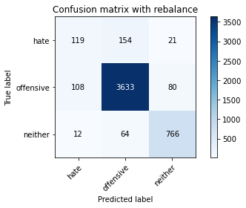

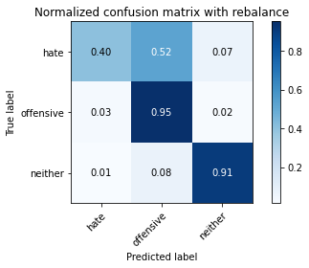

precision recall f1-score support

hate 0.50 0.40 0.45 294

offensive 0.94 0.95 0.95 3821

neither 0.88 0.91 0.90 842

accuracy 0.91 4957

macro avg 0.77 0.76 0.76 4957

weighted avg 0.91 0.91 0.91 4957

average eval_loss: 0.24459094158373773, accuracy: 0.9114383699818439

training 2 epoch...

514.1400909423828 seconds used......

2 training finished! average train loss: 0.20173124323182198

evaluating...

Confusion matrix, without normalization

[[ 38 235 21]

[ 19 3722 80]

[ 1 82 759]]

Normalized confusion matrix

[[0.1292517 0.79931973 0.07142857]

[0.00497252 0.97409055 0.02093693]

[0.00118765 0.09738717 0.90142518]]

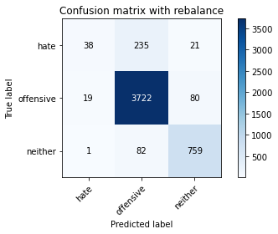

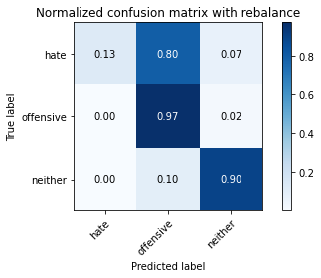

precision recall f1-score support

hate 0.66 0.13 0.22 294

offensive 0.92 0.97 0.95 3821

neither 0.88 0.90 0.89 842

accuracy 0.91 4957

macro avg 0.82 0.67 0.68 4957

weighted avg 0.90 0.91 0.89 4957

average eval_loss: 0.24255428930384018, accuracy: 0.9116401049021585

training 3 epoch...

514.1492748260498 seconds used......

3 training finished! average train loss: 0.14130481676106538

evaluating...

Confusion matrix, without normalization

[[ 82 193 19]

[ 66 3665 90]

[ 8 53 781]]

Normalized confusion matrix

[[0.27891156 0.65646259 0.06462585]

[0.01727297 0.95917299 0.02355404]

[0.00950119 0.06294537 0.92755344]]

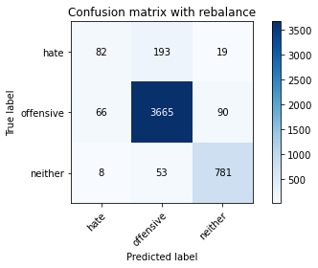

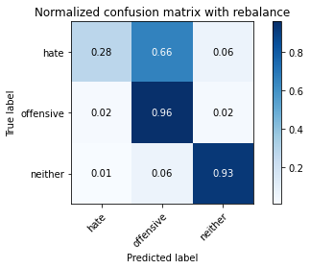

precision recall f1-score support

hate 0.53 0.28 0.36 294

offensive 0.94 0.96 0.95 3821

neither 0.88 0.93 0.90 842

accuracy 0.91 4957

macro avg 0.78 0.72 0.74 4957

weighted avg 0.90 0.91 0.91 4957

average eval_loss: 0.2829528405901886, accuracy: 0.9134557191849909

training 4 epoch...

514.4091498851776 seconds used......

4 training finished! average train loss: 0.08426458201774362

evaluating...

Confusion matrix, without normalization

[[ 84 185 25]

[ 68 3658 95]

[ 10 62 770]]

Normalized confusion matrix

[[0.28571429 0.6292517 0.08503401]

[0.01779639 0.95734101 0.0248626 ]

[0.01187648 0.0736342 0.91448931]]

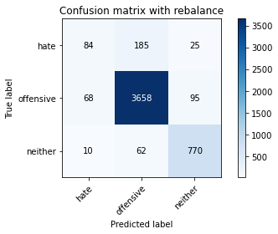

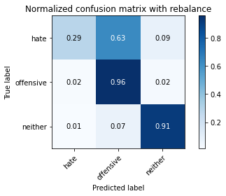

precision recall f1-score support

hate 0.52 0.29 0.37 294

offensive 0.94 0.96 0.95 3821

neither 0.87 0.91 0.89 842

accuracy 0.91 4957

macro avg 0.77 0.72 0.73 4957

weighted avg 0.90 0.91 0.90 4957

average eval_loss: 0.3351198236477719, accuracy: 0.9102279604599556

training 5 epoch...

514.0644097328186 seconds used......

5 training finished! average train loss: 0.043674948950308226

evaluating...

Confusion matrix, without normalization

[[ 110 171 13]

[ 100 3674 47]

[ 20 112 710]]

Normalized confusion matrix

[[0.37414966 0.58163265 0.04421769]

[0.02617116 0.9615284 0.01230044]

[0.02375297 0.13301663 0.8432304 ]]

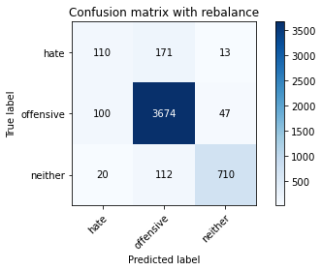

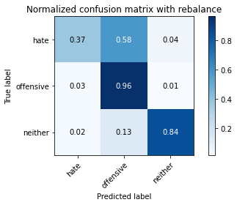

precision recall f1-score support

hate 0.48 0.37 0.42 294

offensive 0.93 0.96 0.94 3821

neither 0.92 0.84 0.88 842

accuracy 0.91 4957

macro avg 0.78 0.73 0.75 4957

weighted avg 0.90 0.91 0.90 4957

average eval_loss: 0.3804072542407084, accuracy: 0.9065967318942909

4 run......

training 1 epoch...

514.0961103439331 seconds used......

1 training finished! average train loss: 0.28660871210365346

evaluating...

Confusion matrix, without normalization

[[ 38 224 32]

[ 22 3709 90]

[ 7 43 792]]

Normalized confusion matrix

[[0.1292517 0.76190476 0.10884354]

[0.00575766 0.9706883 0.02355404]

[0.00831354 0.05106888 0.94061758]]

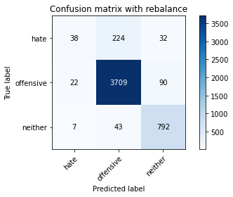

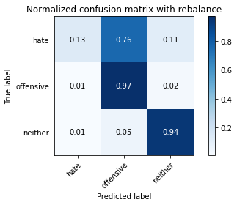

precision recall f1-score support

hate 0.57 0.13 0.21 294

offensive 0.93 0.97 0.95 3821

neither 0.87 0.94 0.90 842

accuracy 0.92 4957

macro avg 0.79 0.68 0.69 4957

weighted avg 0.90 0.92 0.90 4957

average eval_loss: 0.24496581561998615, accuracy: 0.9156748033084527

training 2 epoch...

514.5304758548737 seconds used......

2 training finished! average train loss: 0.20606172493388575

evaluating...

Confusion matrix, without normalization

[[ 122 142 30]

[ 116 3585 120]

[ 6 30 806]]

Normalized confusion matrix

[[0.41496599 0.4829932 0.10204082]

[0.03035854 0.93823606 0.03140539]

[0.00712589 0.03562945 0.95724466]]

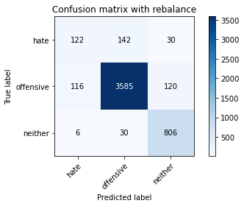

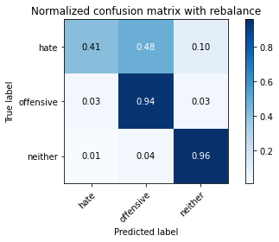

precision recall f1-score support

hate 0.50 0.41 0.45 294

offensive 0.95 0.94 0.95 3821

neither 0.84 0.96 0.90 842

accuracy 0.91 4957

macro avg 0.77 0.77 0.77 4957

weighted avg 0.91 0.91 0.91 4957

average eval_loss: 0.2576346462930463, accuracy: 0.9104296953802703

training 3 epoch...

514.2665627002716 seconds used......

3 training finished! average train loss: 0.15272636142805324

evaluating...

Confusion matrix, without normalization

[[ 146 131 17]

[ 157 3593 71]

[ 23 63 756]]

Normalized confusion matrix

[[0.49659864 0.44557823 0.05782313]

[0.04108872 0.94032976 0.01858152]

[0.02731591 0.07482185 0.89786223]]

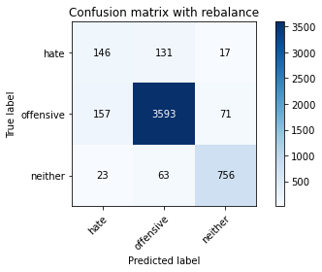

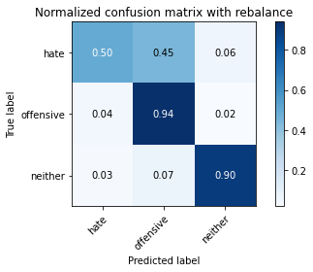

precision recall f1-score support

hate 0.45 0.50 0.47 294

offensive 0.95 0.94 0.94 3821

neither 0.90 0.90 0.90 842

accuracy 0.91 4957

macro avg 0.76 0.78 0.77 4957

weighted avg 0.91 0.91 0.91 4957

average eval_loss: 0.27009327971421543, accuracy: 0.9067984668146056

training 4 epoch...

514.1308252811432 seconds used......

4 training finished! average train loss: 0.09672225605472998

evaluating...

Confusion matrix, without normalization

[[ 81 199 14]

[ 75 3687 59]

[ 11 99 732]]

Normalized confusion matrix

[[0.2755102 0.67687075 0.04761905]

[0.01962837 0.96493065 0.01544098]

[0.01306413 0.1175772 0.86935867]]

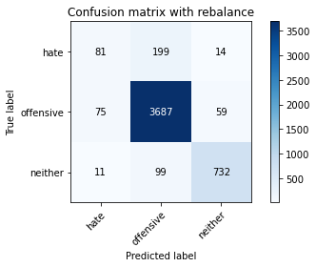

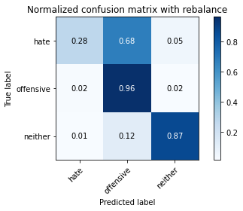

precision recall f1-score support

hate 0.49 0.28 0.35 294

offensive 0.93 0.96 0.94 3821

neither 0.91 0.87 0.89 842

accuracy 0.91 4957

macro avg 0.77 0.70 0.73 4957

weighted avg 0.90 0.91 0.90 4957

average eval_loss: 0.31886918422570754, accuracy: 0.9078071414161791

training 5 epoch...

513.9428234100342 seconds used......

5 training finished! average train loss: 0.05627407236422568

evaluating...

Confusion matrix, without normalization

[[ 108 174 12]

[ 118 3660 43]

[ 21 136 685]]

Normalized confusion matrix

[[0.36734694 0.59183673 0.04081633]

[0.03088197 0.95786443 0.0112536 ]

[0.02494062 0.16152019 0.81353919]]

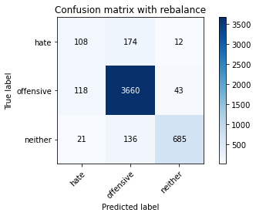

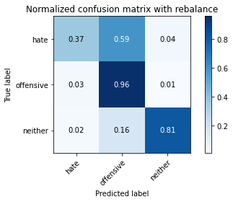

precision recall f1-score support

hate 0.44 0.37 0.40 294

offensive 0.92 0.96 0.94 3821

neither 0.93 0.81 0.87 842

accuracy 0.90 4957

macro avg 0.76 0.71 0.73 4957

weighted avg 0.89 0.90 0.90 4957

average eval_loss: 0.4321821124012199, accuracy: 0.898325600161388

5 run......

<tqdm.auto.tqdm object at 0x7fe0b1942950>

<tqdm.auto.tqdm object at 0x7fe0b193c290>

training 1 epoch...

516.8456189632416 seconds used......

1 training finished! average train loss: 0.28695478000971036

evaluating...

Confusion matrix, without normalization

[[ 100 160 34]

[ 83 3648 90]

[ 6 46 790]]

Normalized confusion matrix

[[0.34013605 0.54421769 0.11564626]

[0.02172206 0.95472389 0.02355404]

[0.00712589 0.05463183 0.93824228]]

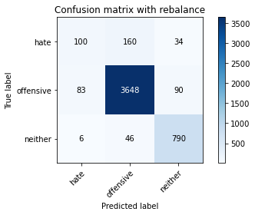

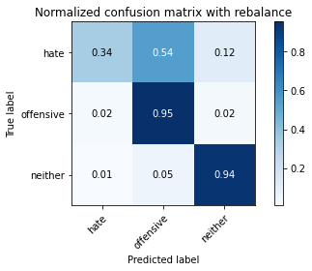

precision recall f1-score support

hate 0.53 0.34 0.41 294

offensive 0.95 0.95 0.95 3821

neither 0.86 0.94 0.90 842

accuracy 0.92 4957

macro avg 0.78 0.74 0.75 4957

weighted avg 0.91 0.92 0.91 4957

average eval_loss: 0.23476707813660463, accuracy: 0.915473068388138

training 2 epoch...

516.2679886817932 seconds used......

2 training finished! average train loss: 0.20583306046319194

evaluating...

Confusion matrix, without normalization

[[ 129 147 18]

[ 98 3646 77]

[ 12 61 769]]

Normalized confusion matrix

[[0.43877551 0.5 0.06122449]

[0.02564774 0.95420047 0.02015179]

[0.01425178 0.07244656 0.91330166]]

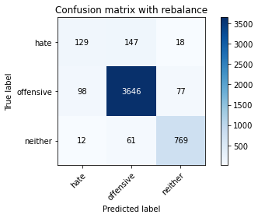

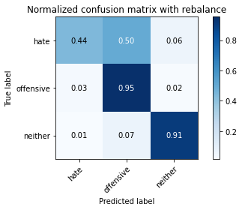

precision recall f1-score support

hate 0.54 0.44 0.48 294

offensive 0.95 0.95 0.95 3821

neither 0.89 0.91 0.90 842

accuracy 0.92 4957

macro avg 0.79 0.77 0.78 4957

weighted avg 0.91 0.92 0.91 4957

average eval_loss: 0.24007786634272985, accuracy: 0.9166834779100262

training 3 epoch...

516.6166353225708 seconds used......

3 training finished! average train loss: 0.15023581395366964

evaluating...

Confusion matrix, without normalization

[[ 103 178 13]

[ 64 3695 62]

[ 16 85 741]]

Normalized confusion matrix

[[0.35034014 0.60544218 0.04421769]

[0.01674954 0.96702434 0.01622612]

[0.01900238 0.10095012 0.88004751]]

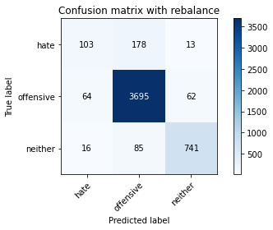

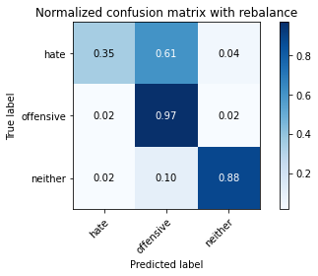

precision recall f1-score support

hate 0.56 0.35 0.43 294

offensive 0.93 0.97 0.95 3821

neither 0.91 0.88 0.89 842

accuracy 0.92 4957

macro avg 0.80 0.73 0.76 4957

weighted avg 0.91 0.92 0.91 4957

average eval_loss: 0.2719655214224927, accuracy: 0.9156748033084527

training 4 epoch...

516.7032222747803 seconds used......

4 training finished! average train loss: 0.09219750234326292

evaluating...

Confusion matrix, without normalization

[[ 89 180 25]

[ 103 3627 91]

[ 10 69 763]]

Normalized confusion matrix

[[0.30272109 0.6122449 0.08503401]

[0.02695629 0.94922795 0.02381576]

[0.01187648 0.08194774 0.90617577]]

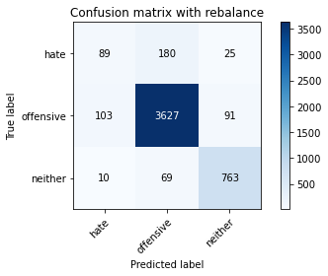

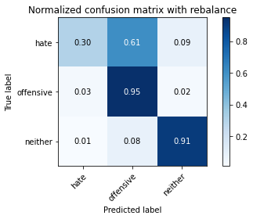

precision recall f1-score support

hate 0.44 0.30 0.36 294

offensive 0.94 0.95 0.94 3821

neither 0.87 0.91 0.89 842

accuracy 0.90 4957

macro avg 0.75 0.72 0.73 4957

weighted avg 0.89 0.90 0.90 4957

average eval_loss: 0.3405790511577863, accuracy: 0.9035707080895703

training 5 epoch...

516.4715449810028 seconds used......

5 training finished! average train loss: 0.04886532689341684

evaluating...

Confusion matrix, without normalization

[[ 95 176 23]

[ 93 3672 56]

[ 10 93 739]]

Normalized confusion matrix

[[0.32312925 0.59863946 0.07823129]

[0.02433918 0.96100497 0.01465585]

[0.01187648 0.11045131 0.87767221]]

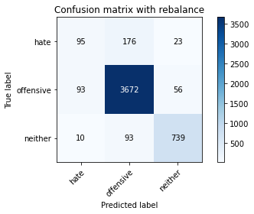

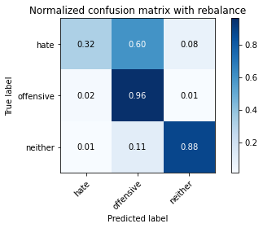

precision recall f1-score support

hate 0.48 0.32 0.39 294

offensive 0.93 0.96 0.95 3821

neither 0.90 0.88 0.89 842

accuracy 0.91 4957

macro avg 0.77 0.72 0.74 4957

weighted avg 0.90 0.91 0.90 4957

average eval_loss: 0.42104382938240664, accuracy: 0.9090175509380674